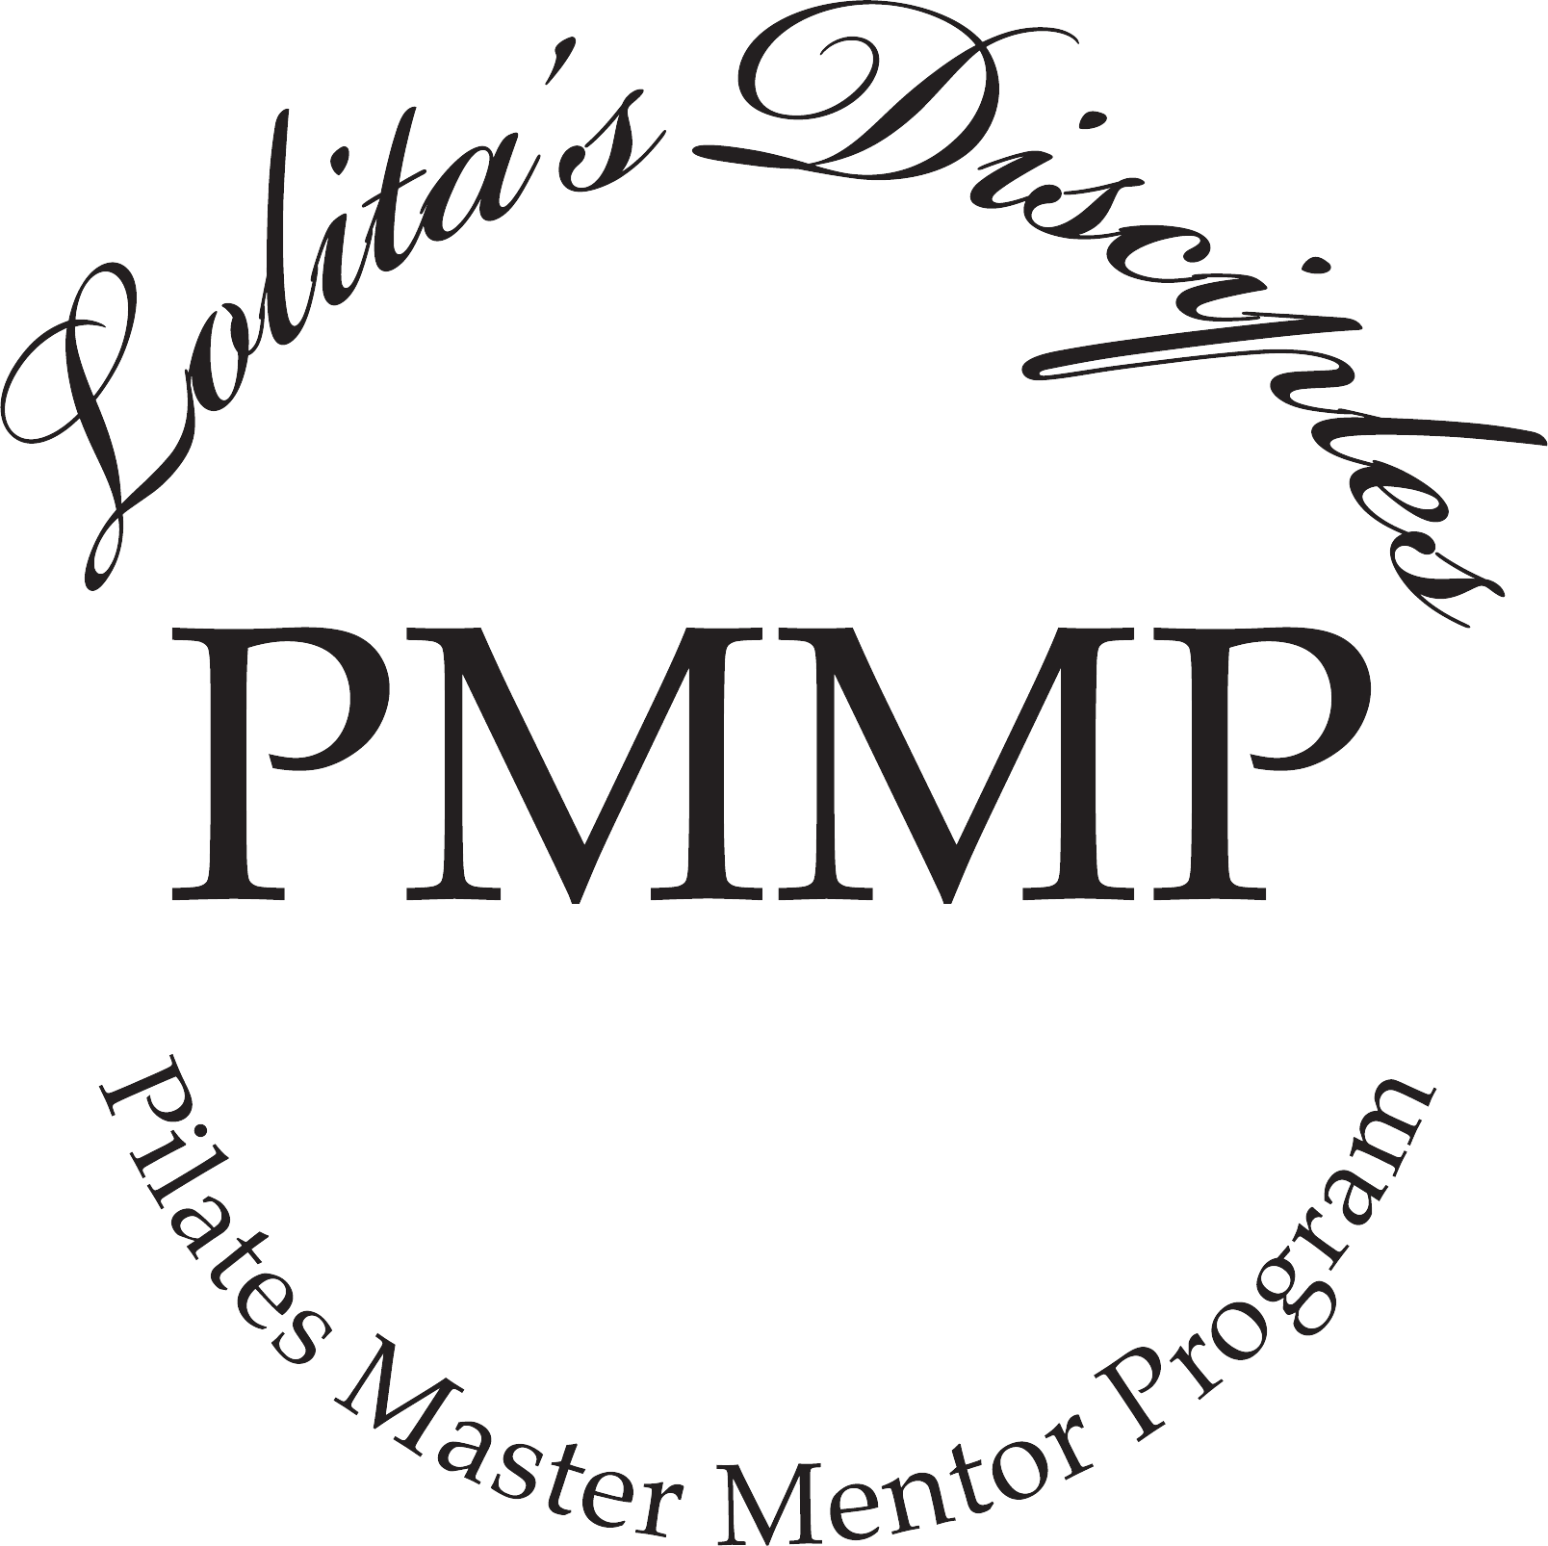

Enrollment Agreement Pilates Master Mentor Program

Waiver of Liability and Informed Consent

I, (Please print your name), hereby agree to the following:

- That I am voluntarily participating in the Pilates Master Mentor Program (hereinafter called “The Program”) offered by Ms. San Miguel, during which I will receive information and instruction. I recognize that this fitness program involves physical contact and requires physical exertion which may be strenuous and may cause physical injury, and I am fully aware of the risks and hazards involved.

- I understand that it is my responsibility to consult with a physician prior to and regarding my participation in The Program. I represent and warrant that I am physically fit and I have no medical condition which would prevent my full participation. I agree to assume full responsibility for any risks, injuries or damages, known or unknown which I might incur as a result of participating in The Program.
- In further consideration of being permitted to participate in The Program I voluntarily and expressly agree to hold harmless Ms. San Miguel and The Program, their officers, agents, instructors or employees from and against any and all claims, loss, injury, damage, cost, charges and expenses, including attorney’s fees, which the undersigned may suffer, such as any injury or death caused by their negligence or other acts, as a result of participating in The Program.

- The undersigned agrees that no refunds will be given during the course and acknowledges full responsibility for payment in its totality once enrolled.
- I understand that until I complete all of the 160 hours of instruction I will not be eligible to receive the Pilates Master Diploma signed by Ms. San Miguel, nor do I have any right to use the terms “Pilates Master” and/or Lolita’s Disciple™ unless I have completed all the course and financial requirements of the course and been awarded the Diploma signed by Ms. San Miguel.
- The course requires that you pass with a 75 + score on each of the sessions. Make up or retake sessions are available at a 50% of the cost.
I have read the above enrollment form and waiver of liability and fully understand its contents as well as the Refund/Cancellation Policies. I voluntarily agree to the terms and conditions stated above.
Signature: Date:

Please print your name:

* An executed enrollment agreement will be required before you begin the Master Mentor Program.

1

